Name
Institution
Date
Labour Market

The oil industry developed to meet an increasing fuel need over the last 200 years. Companies in the oil industry discover reserves of these resources at sea or in the ground. In 2014, according to the US Energy Information Administration, about 60 percent of consumed oil was used in transportation including automobile, truck fuel, airplane, bus, and ship. With the oil industry is the term labour market. Labour market refers to the supply of employees in the oil industry who are willing and able to work concerning the number of jobs available. “The landscape of global oil production over the last decade has dramatically shifted contributed by new technology revolution.” (Jothen, Kunin & British Columbia, 2007)
Ten years from now, the future of the labour market in the oil industry will have changed entirely. In the United States, the oil industry has taken a hit. The labour market in the industry can be termed to decrease in the next ten years due to the innovation of solar cars and manufacture of energy saving machinery. What this implies to the labour market is the possibility of low demand (Lalive & Zweimüller, 2002)
As the oil prices decline, so do jobs in the next ten years.
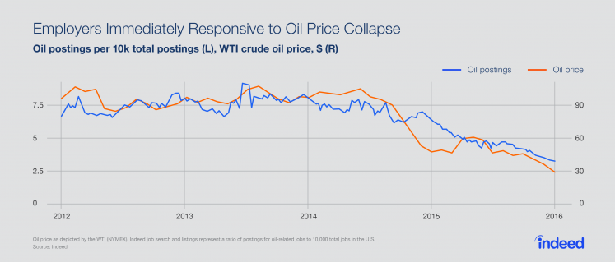

From the chart, there is a robust impact on the oil industry by the oil price. What this implies to the labour market is a decline in demand. In the next ten years, the trend is likely to dominate since oil prices decline will continue to dominate. There will be a downward movement of the oil prices resulting in low demand of the labour market. Innovation in technology has made it possible for people to be replaced by machines. If a particular job in the oil industry requires five individuals, one specific device will be able to perform the situation leading to labour market decreased demand (Jothen, Kunin & British Columbia, 2007)
The other prediction will be in terms of qualifications. In the next ten years, the oil industry will require the labour market to be skilful. Companies in the oil industry will be hiring the best and employees will be fighting for the best satisfying jobs to their needs. The industry will provide a valuable competitive edge. Training and development opportunities will be essential in securing jobs. There will be the need to adapt to changes in the next ten years failure to which incompetence will result. In the next ten years, innovative approaches will be enhanced to retain and recruit talent which will be essential for long-term success. Currently, the human cost of restricting has been enormous with the oil industry. The industry has been depriving some of its smartest talents through downsizing while recruits have been scared away. While this is done, there are still opportunities that the oil industry should not pass up. In the next ten years, from a management perspective, the labour market will enhance new talent recruitment from pools of highly payable women and men. Oil companies will be engaging with recent graduates due to their ability to provide new ideas that will make it easier to navigate the future. “There will a bright and attractive storyline by oil companies since it will be more accessible to engage younger employees.” (Lalive & Zweimüller, 2002) More collaboration and open communication will be enhanced leading to effective decisions on job performance.
The figure below indicates how there has been an increase in the supply of oil. The trend is likely to increase in the next ten years since labour market will be experienced due to effective education programmes. 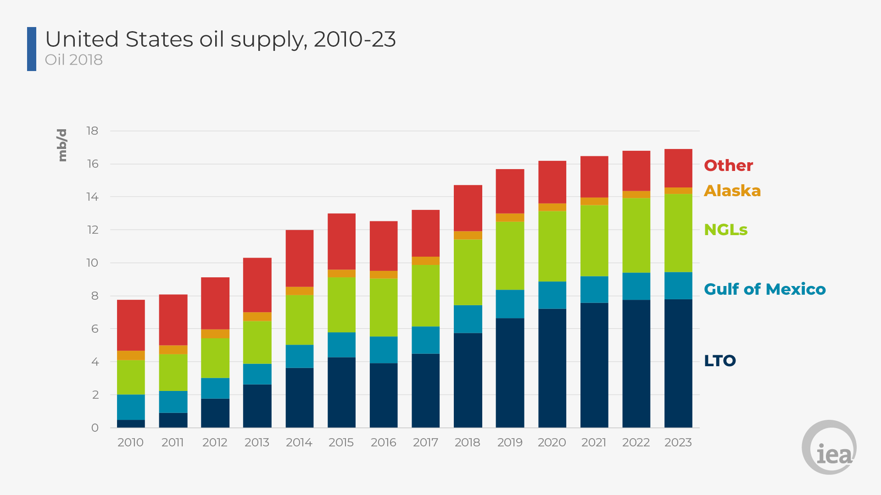
In conclusion, labour market in the oil industry is seen to be changing. In the next ten years, skills and qualifications will be influential in determining who secure positions in this industry. Individuals should be ready for change since technology innovations are laying foundations on how work will be done in this industry. Failure to adopt these changes will result many individuals losing positions to work in the oil industry (Jothen, Kunin & British Columbia, 2007)

References
Jothen, K., Kunin, R., & British Columbia. (2007). Labour market needs in British Columbia's oil and gas industry. Victoria, B.C: British Columbia Ministry of Energy, Mines and Petroleum Resources.
Lalive, R., & Zweimüller, J. (2002). Benefit entitlement and the labor market: Evidence from a large-scale policy change. Bonn: IZA.

